A 10-bit ADC with an input range of 0–10 V produces the quantized output 6.24 V for an input of 6.28 V. The engineer reports the quantization error as 0.12 V. Verify the calculation, identify the error, and compute the correct quantization error.
MATLAB Code:
clc;
clear;
close all;
%% Given values
Vin = 6.28;
Vq = 6.24;
reported_error = 0.12;
%% Error calculation
actual_error = abs(Vin - Vq);
%% Display
fprintf('Input Voltage = %.2f V\n', Vin);
fprintf('Quantized Voltage = %.2f V\n', Vq);
fprintf('Actual Quantization Error = %.2f V\n', actual_error);
fprintf('Reported Error = %.2f V\n', reported_error);
%% Plot comparison
figure;
values = [Vin Vq];
bar(values);
set(gca, 'XTickLabel', {'Input Voltage','Quantized Voltage'});
ylabel('Voltage (V)');
title('ADC Input and Quantized Output');
grid on;
%% Error plot
figure;
bar([actual_error reported_error]);
set(gca, 'XTickLabel', {'Actual Error','Reported Error'});
ylabel('Error (V)');
title('Comparison of Quantization Error');
grid on;
OUTPUT:
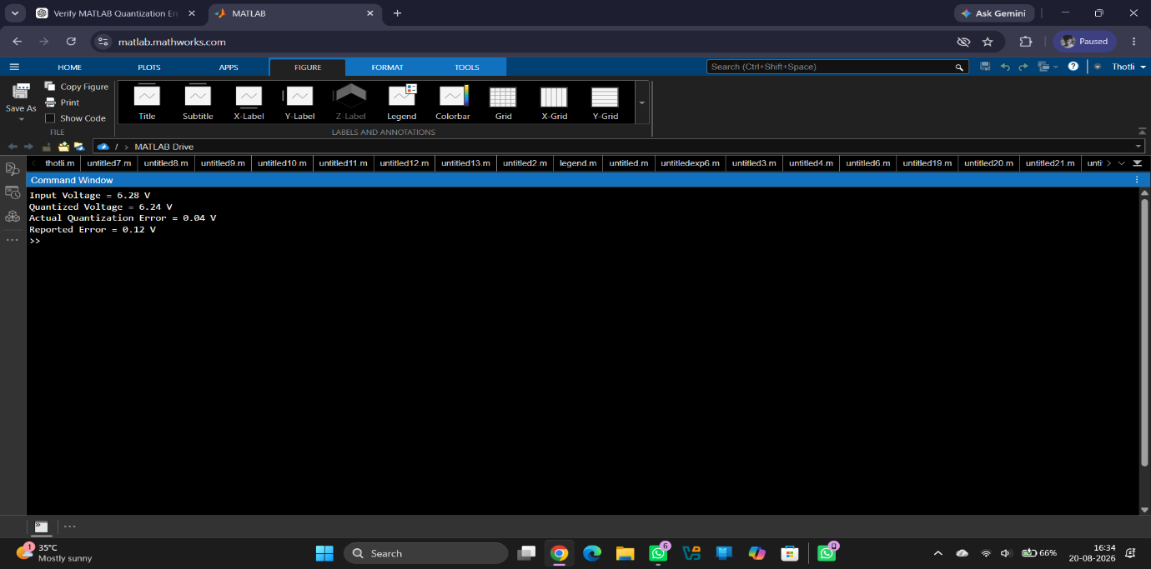
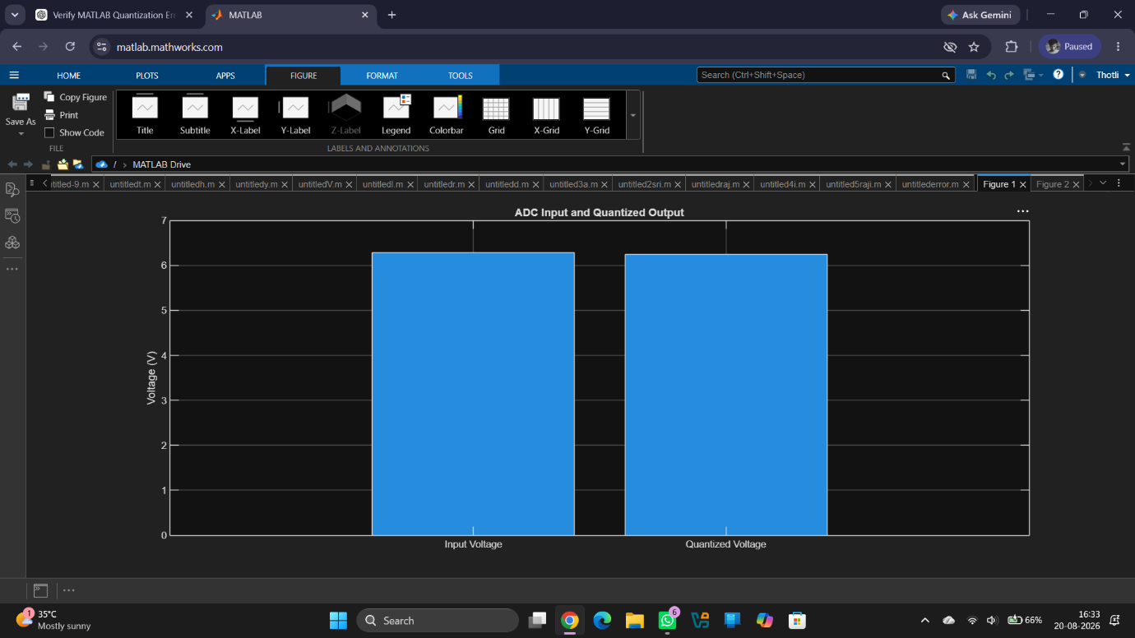
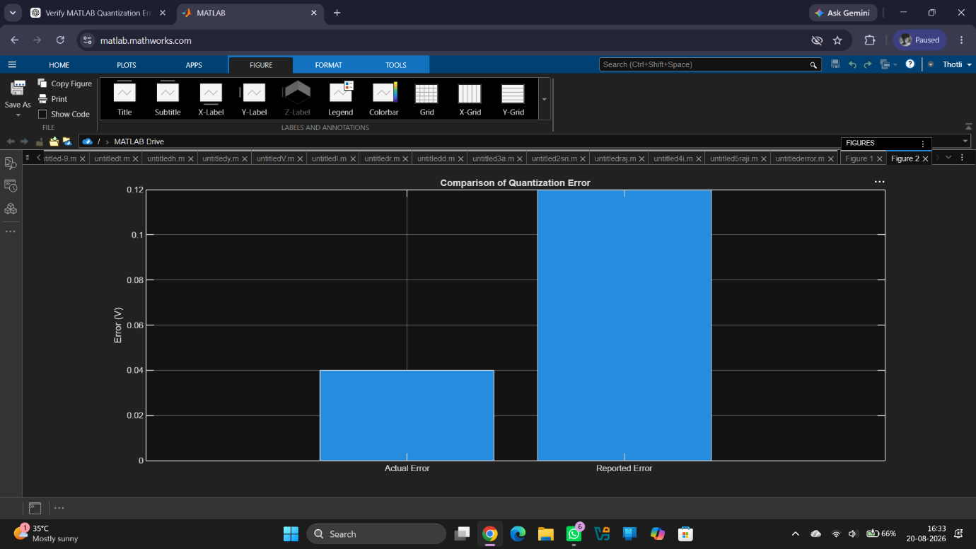
Comparison of Actual and Reported Quantization Error
Eq=|Vin-Vq|
Eq=|6.28-6.24|
Eq=0.04V
The engineer reported the error as 0.12 V, which is incorrect.
RESULT:
The quantization error was verified using MATLAB. The correct quantization error is 0.04 V, whereas the engineer reported 0.12 V. Hence, the reported calculation is incorrect.

